How to use the GAIHN HAI PPS data analysis tool for automated report generation
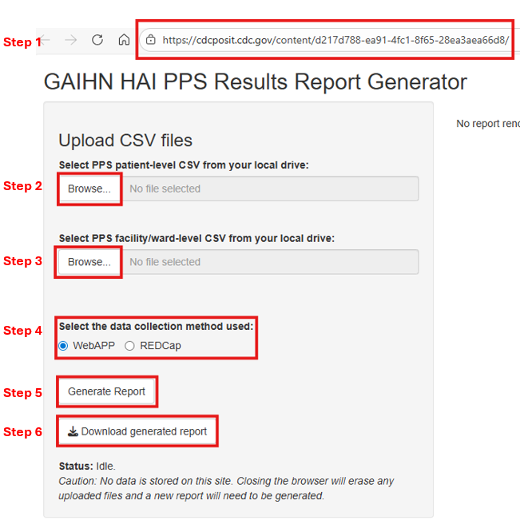
Step 1: Go to https://cdcposit.cdc.gov/content/d217d788-ea91-4fc1-8f65-28ea3aea66d8/
Step 2: Click on Browse to upload your facility PPS patient-level CSV file
Note: Make sure to export data from one facility only and upload the raw, unedited output file exported from the WebApp or the REDCap.
If the files are even opened in excel and then resaved, it leads to errors with the analysis and report generation.
Step 3: Click on Browse to upload your facility PPS facility/ward-level CSV file
Note: Make sure to upload the raw, unedited output file exported from the WebApp or the REDCap.
Step 4: Select the Data collection method used at your facility
Step 5: Click on Generate Report
Step 6: Click on Download the generated report to save the report
Note: No data is stored on the website. Closing the browser will erase any uploaded files and report generated.

